CS 4354 Database Systems
Midterm 2

Name:____Chen Zhang_________________

Question 1. (10 pts)

Consider the BANK ER schema of the following figure (Figure 7.21), and suppose that it is necessary to keep track of different types of ACCOUNTS (SAVINGS_ACCTS, CHECKING_ACCTS,...) and LOANS (CAR_LOANS, HOME_LOANS, ...). Suppose that it is also desirable to keep track of each account's TRANSACTIONs (deposits, withdrawals, checks, ...) and each loan's PAYMENTs; both of these include the amount, date, time, ... Modify the BANK schema, using ER and EER concepts of specialization and generalization.

Answer:

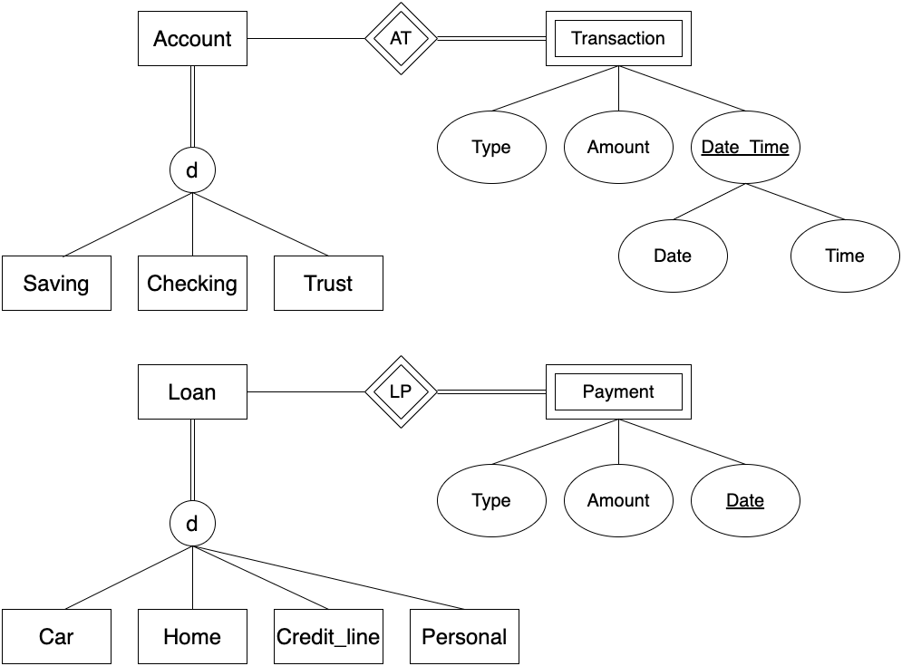
Question 2. (8 pts)

Figure out the cardinality of each relationship in the ER schema in the following figure, then map the ER schema into a relational schema. State any assumptions you make if you have.

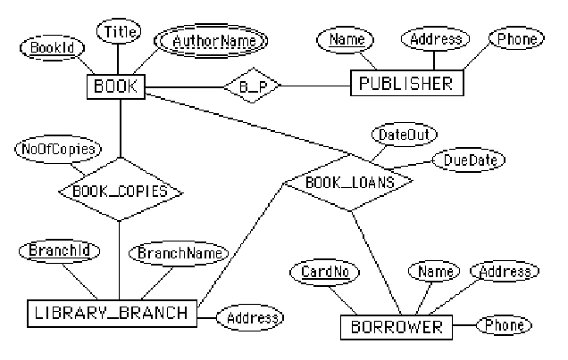

Answer:
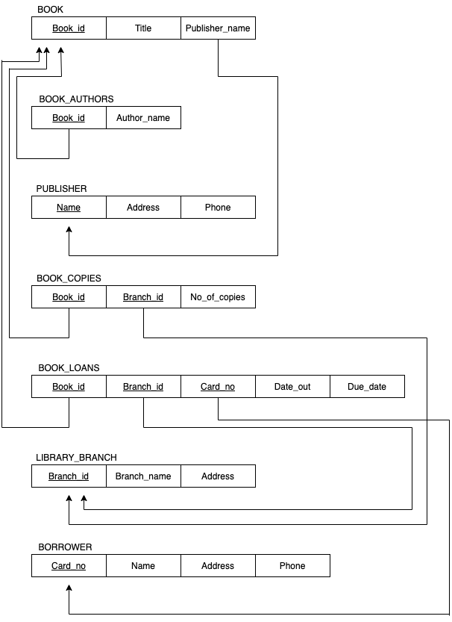

Question 3. (7 pts)

Consider the database schema (not complete) is shown in the following figure (the database is shown in Question 3). What are the primary keys and the referential integrity constraints that should hold on the schema? Write appropriate SQL DDL statements to define the database. Specify the keys and referential triggered actions.

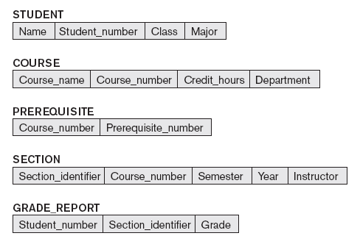
Answer:

Referential integrity constraints and primary keys:
PREREQUISITE(Course_number) -> COURSE(Course_number)
PREREQUISITE(Prerequisite_number) -> COURSE(Course_number)
SECTION(Course_number) -> COURSE(Course_number)
GRADE_REPORT(Student_number) -> STUDENT(Student_number)
GRADE_REPORT(Section_identifier) -> SECTION(Section_identifier)

SQL Statements:
- STUDENT table
CREATE TABLE STUDENT (Name varchar(50) NOT NULL, Student_number INTEGER NOT NULL, Class char(20) NOT NULL, Major varchar(20), PRIMARY KEY (Student_number));
- COURSE table
CREATE TABLE COURSE(Course_name varchar(50) NOT NULL, Course_number char(10) NOT NULL, Credit_hours INTEGER, Department char(5), PRIMARY KEY (Course_number), UNIQUE(Course_name));
- PREREQUISITE table
CREATE TALBE PREREQUISITE(Course_number char(10) NOT NULL, Prerequisite_number char(10) NOT NULL, PRIMARY KEY (Course_number, Prerequisite_number), FOREIGN KEY (Course_number) REFERENCES COURSE (Course_number) ON DELETE CASCADE ON UPDATE CASCADE, FOREIGN KEY (Prerequisite_number) REFERENCES COURSE (Course_number));
- SECTION table
CREATE TABLE SECTION(Section_identifier INTEGER NOT NULL, Course_number char(10) NOT NULL, Semester varchar(10) NOT NULL, Year char(4) NOT NULL, Instructor varchar(20), PRIMARY KEY (Section_identifier), FOREIGN KEY (Course_number) REFERENCES COURSE (Course_number) ON DELETE CASCADE ON UPDATE CASCADE);
- GRADE_REPORT table
CREATE TABLE GRADE_REPORT (Student_number INTEGER NOT NULL, Section_identifier INTEGER NOT NULL, Grade char, PRIMARY KEY (Student_number, Section_identifier), FOREIGN KEY (Student_number) REFERENCES STUDENT (Student_number) ON DELETE CASCADE ON UPDATE CASCADE, FOREIGN KEY (Section_identifier) REFERENCES SECTION (Section_identifier) ON DELETE CASCADE ON UPDATE CASCADE);

Question 4. (9 pts)

Specify the following queries in SQL on the database schema shown in Question 2 and its database shown in the following figure. Show the result of each query if it is applied to the database.

(a) Retrieve the names of all students majoring in 'CS' (computer science).

(b) Retrieve the names of all courses taught by professor Anderson in the year 07 and 08.

(c) Retrieve the name and transcript of each student (Class=5) majoring in
CS. Transcript includes course name, course number, credit hours, semester, year,
and grade for each course completed by the student.

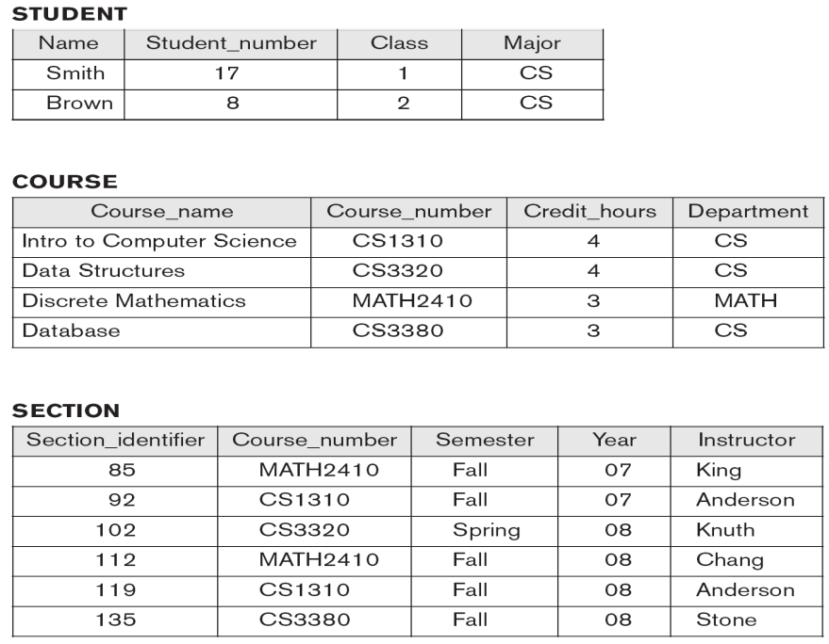
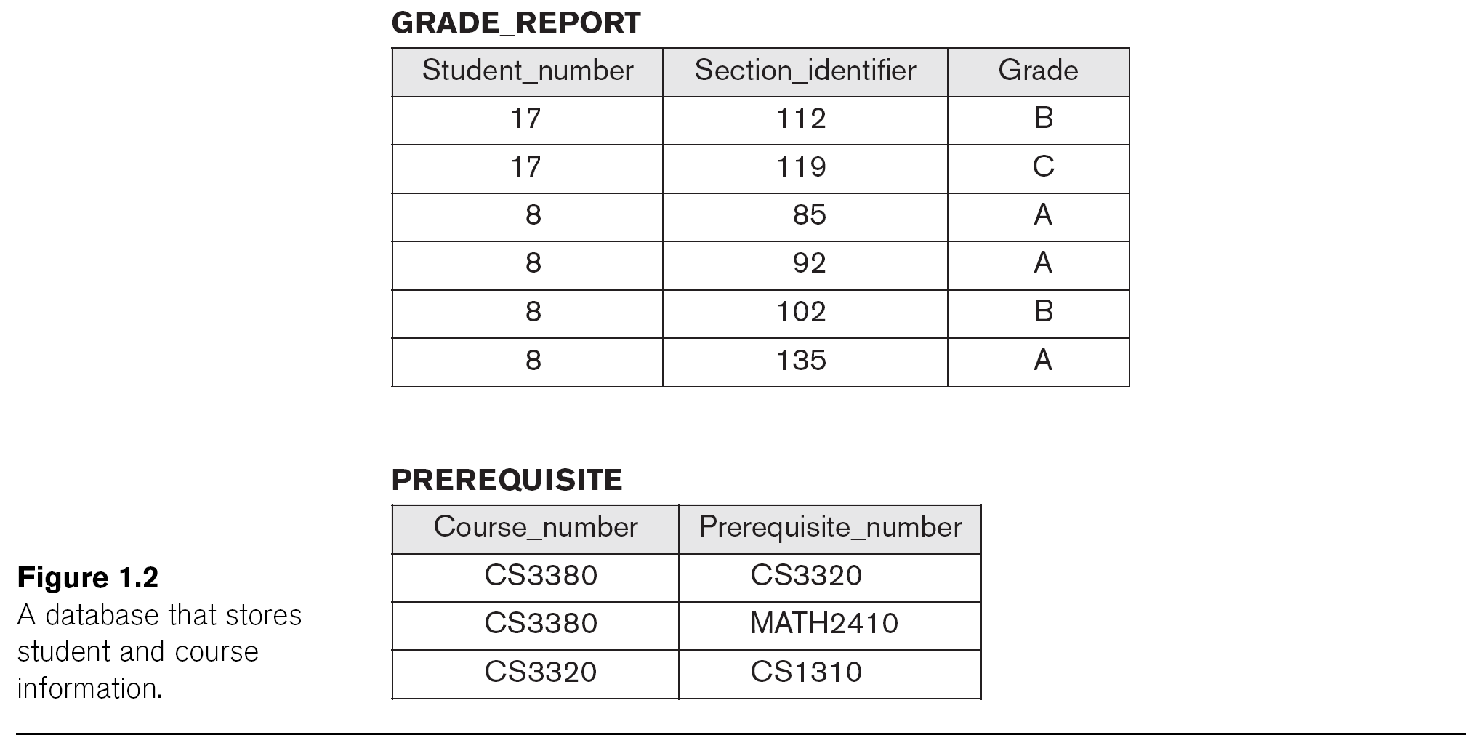

Answer:
- SELECT S.Name FROM STUDENT S WHERE S.Major = ‘CS’
Result:
Smith
Brown

- SELECT C.Course_name FROM COURSE C, SECTION S WHERE C.Course_number = S.Course_number and S.Instructor = ‘Anderson’
Result:
Intro to Computer Science

- SELECT ST.Name, C.Course_name, C.Course_number, C.Credit_hours, SE.Semester, SE.Year, G.Grade FROM STUDENT ST, COURSE C, SECTION SE, GRADE_REPORT G WHERE ST.Class = '5' and ST.Major = 'CS' and ST.Student_number = G.Student_number and G.Section_identifier = SE.Section_identifier and SE.Course_number = C.Course_number;

